**6. Setting up Hibernate in Eclipse**

**Setting up Hibernate in Eclipse**:

For setting up Hibernate in eclipse we have to do the following steps

1. Create an eclipse project
2. Download Hibernate JAR (<http://hibernate.org/orm/releases/5.4/>)

Extract file and copy jar from the path **hibernate-release-5.4.2.Final\lib\required**

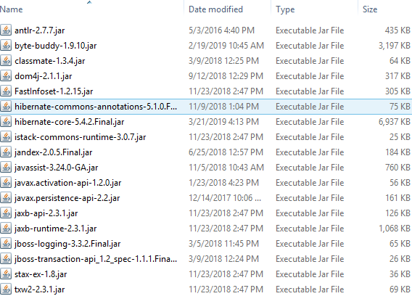

1. Download MySQL JDBC driver (<https://dev.mysql.com/downloads/connector/j/>)

Extract file and copy jar **mysql-connector-java-8.0.15**

1. Add JAR files to Eclipse Project Build Path
   1. Create simple Java project
   2. Create a lib folder in the project and past the **Hibernate** and **mysql-connector-java** JAR file.
   3. Add the JAR file to project class path.

**Right click on project -> Java Build Path -> Libraries -> Add JARs -> Select JARs ->Ok -> Apply and Close**

6. Setting up Hibernate in Eclipse